“Solar Panels: at Gallaudet Campus”

1. Use more solar panels to absorb sunlight from sunlight conversation to electricity. Help with electric storage more.
   1. Link for solar panel benefits in school: <https://sustainablesolutions.duke-energy.com/resources/benefits-of-solar-panels-for-schools/>
   2. A links of solar energy storage work:

<https://www.aurorasolar.com/blog/how-solar-energy-storage-works/>

* 1. <https://www.consumeraffairs.com/solar-energy/how-much-do-solar-panels-cost.html>
  2. <https://www.kcgreenenergy.com/blog/businesses-benefits-solar-installation/>

Solar panels can improve school electric bills and storage electric for emergencies?

In two months plans:

1. We can test solar panels to see how much energy we receive and save electricity by comparing with and without. Or talk with KIPP school to use their solar panels and collect their data.
2. Research another university or school how much they save and benefits for them.
3. Discuss where the location should be on Gallaudet for solar panels installation
4. Discuss which kind of solar panels to use to benefit and compare which is better to use for Gallaudet.

**Team Responsible:**

**IT**: set up and install the solar panel on the campus

**Math**: calculate the data how much save energy and money stuff

**Biology**: research and look for the safest way to install on grass or air stuff or the shade?

**Public health**: A team leader to ensure we do the job and monitor the data.

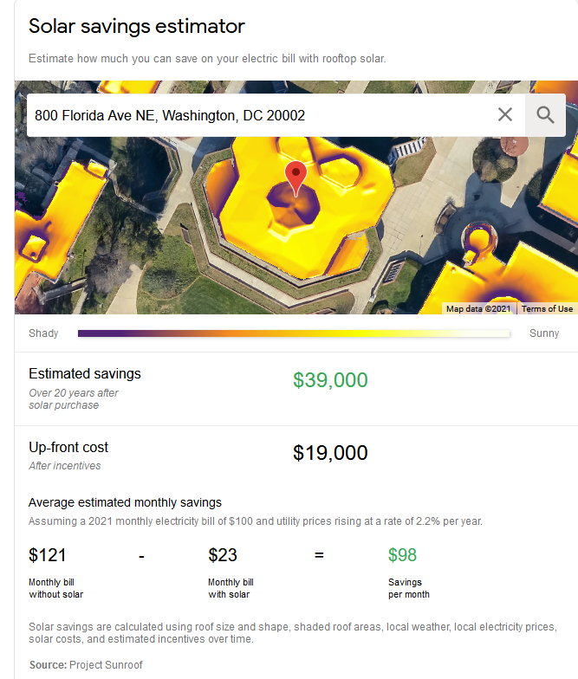

**Assign roles**

Team leader:

•Facilitate discussions but not dominate discussions, because leading people down a path means you won’t likely get as many perspectives.

**Elina**

•Voice when the team seems to reach a consensus, note the decision made, and move to the next topic on the agenda for the meeting.

**Dylan**

Timekeeper:

Good idea to have someone monitor the time the group is spending on brainstorming and development.

**David**

Recorder:

Keep notes on what happened and things that need to happen.

**Larry and Mbisana**

Our responsibility is the recorder that helps our group to remind us which is very important and summarizes what we discuss in every meeting.